JavaScript Functions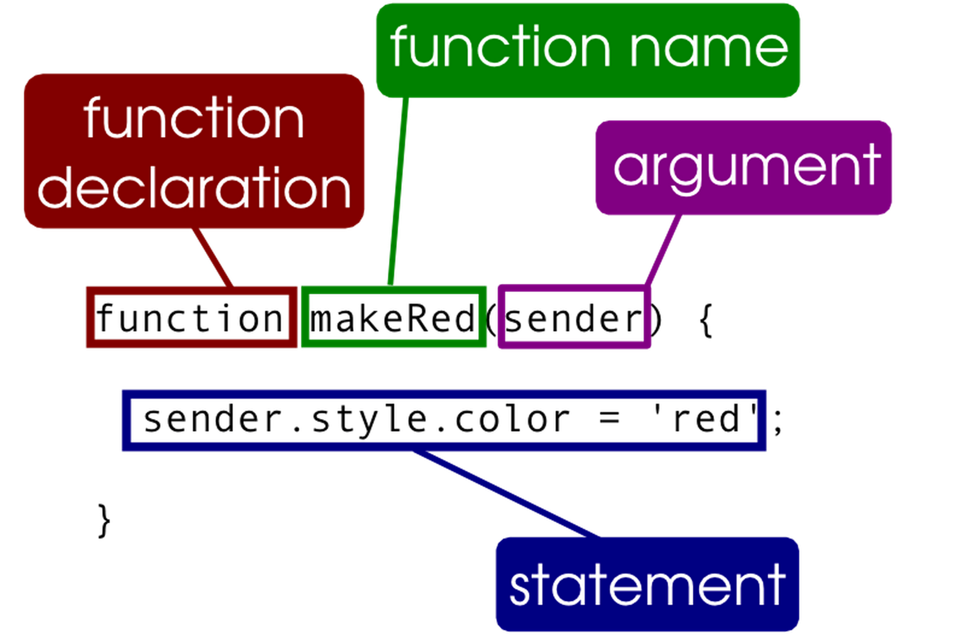

## JavaScript functions and Callbacks

**1)** Create a new JavaScript file and add these three functions

**Function Declaration**

//Observe: no return type, no type on parameters

function add(n1, n2){

return n1 +n2;

}

**Function Expression**

var sub = function(n1,n2){

return n1 - n2

}

**Callback example**

var cb = function(n1,n2, callback){

return "Result from the two numbers: "+n1+"+"+n2+"="+callback(n1,n2);

};

The following questions might seem trivial, but it's extremely important that you can answer (and understand) each, in order to do the JS-stuff we want to do this semester

**2)** Call the functions above as sketched below. It’s not about doing it as fast as you can, but about understanding what's happening, so make sure you understand each line.

1. console.log( add(1,2) ) // What will this print?
2. console.log( add ) // What will it print and what does add represent?
3. console.log( add(1,2,3) ) ; // What will it print
4. console.log( add(1) ); // What will it print
5. console.log( cb(3,3,add) ); // What will it print
6. console.log( cb(4,3,sub) ); // What will it print
7. console.log(cb(3,3,add())); // What will it print (and what was the problem)
8. console.log(cb(3,"hh",add));// What will it print

3) Error Handling

7 will fail due to missing/wrong arguments. But it will fail runtime, not as with Java, at compile time.

We can check arguments in JavaScript as sketched below and provide better errors by throwing our own exceptions:

**typeof n1 === "number"** //Will fail if n1 is undefined, or is not a number

**typeof callback === "function"** //Will fail if callback is undefined or is not a function

Rewrite the Callback function expression (cb) to make a check for all its three required arguments, and throw an Error if any of the arguments do not match as [explained here](https://developer.mozilla.org/en-US/docs/Web/JavaScript/Reference/Global_Objects/Error#Throwing_a_generic_error).

Surround the call to the function with a try-catch block, and provide a more user-friendly error message if the function throws an error

**More Callbacks**

Take another look at the function expression declared in ***cb***, and the provided callbacks in 5+6. What we have in ***cb*** is a very generic function, that can take any callback that can do something with two numbers and return a value.

**4)** Write a mul(n1, n2) function (inspired by add and sub) and use it as the callback for the **cb** function

***5)*** *Call* ***cb****, this time with an anonymous function that divides the first argument with the second*

## Callbacks (with map, filter and forEach)

We saw a simple example of a callback above. Let's get familiar with callbacks, using some of the array-type’s built-in methods.

## Getting comfortable with *filter*, *map* and *forEach*:

**1)** Declare a JavaScript array and initialize it with some names (Lars, Jan, Peter, Bo, Frederik etc.). Use the **filter** method to create a new array with only names of length <=3.

Use the forEach method to iterate and print (console.log) both the original and the new array.

**2)** Use the names-array created above, and, using its **map** method, create a new array with all names uppercased.

*We will continue with this exercise tomorrow when we start manipulating the browser's DOM*

**3)** Use map**,** join + just a little bit more to create a function, which given the array of names, for example: ["Lars", "Peter", "Jan", "Ian"] returns a string with the HTML for the names in an <ul> as sketched below:

<ul>

<li>Lars</li>

<li>Peter</li>

<li>Jan</li>

<li>Ian</li>

<ul>

The output above was shown with newlines for readability, but this is actually what we want (why):

<ul><li>Lars</li><li>Peter</li><li>Jan</li><li>Ian</li><ul>

*Tomorrow we will use DOM manipulation and place this into a “running” web-page.*

**4)** Given this JavaScript array

var cars = [

{ id: 1, year: 1997, make: 'Ford', model: 'E350', price: 3000 },

{ id: 2, year: 1999, make: 'Chevy', model: 'Venture', price: 4900 },

{ id: 3, year: 2000, make: 'Chevy', model: 'Venture', price: 5000 },

{ id: 4, year: 1996, make: 'Jeep', model: 'Grand Cherokee', price: 4799 },

{ id: 5, year: 2005, make: 'Volvo', model: 'V70', price: 44799 }

];

a) Use the filter **filter** function to get arrays with only:

* Cars newer than 1999
* Al Volvo’s
* All cars with a price below 5000
* Can you refactor this into *three* methods, that takes the filter text as an argument.
* Can you refactor this into *one* method, that takes the filter text, and type, as arguments

**4a)** Use **map,** **join** + just a little bit more to implement a function, that , given the cars array used above, will create, and return a string with valid SQL statements to insert the data into a table with matching column names (id, year, make, model, price) as sketched below:

INSERT INTO cars (id,year,make,model,price) VALUES ( 1, 1997 'Ford','E350', 3000 );

...

**4b)** Combine (using chaining) 4 + 4a to create the SQL, only for some of the conditions given in 4

## Asynchronous Callbacks

Most of the javascript callbacks you will be using will be *asynchronous*, in contrary to map, *filter* and forEach which are *synchronous* (MAKE SURE you understand the difference)

**1)** Given the code below answer, don’t execute the code, in what order you would expect to see the outputs:

var msgPrinter = function(msg,delay){

**setTimeout**(function(){

console.log(msg);

},delay);

};

console.log("aaaaaaaaaa");

msgPrinter ("bbbbbbbbbb",2000);

console.log("dddddddddd");

msgPrinter ("eeeeeeeeee",1000);

console.log("ffffffffff");

**2)** Add the code to a javascript file, execute and verify whether you answer to 1) was right

## *this* and *constructor functions*

*The value of* ***this*** *passed to all functions, is based on the context in which the function is called at runtime. Pay attention here, because this is one of those quirks you just need to memorize.*

*In the example below, we actually have two versions of* ***this*** *in play (one for the outer function, and one for the asynchronous callback)*

1) Add this code,

function Person(name){

this.name = name;

console.log("Name: "+ this.name);

setTimeout(function(){

console.log("Hi "+this.name); //Explain this

},2000);

}

//call it like this (do it, even if you know it’s silly ;-)

Person("Kurt Wonnegut"); //This calls the function

console.log("I'm global: "+ name); //Explain this

That was silly. How do we use a function starting with a *capitalized letter?*, and what do we call such a function?

**2)** Create a Person instance and rerun the example as sketched below*:*

var p = new Person("Kurt Wonnegut"); //Create an instance using the constructor function

console.log("I'm global: "+ name); //What’s different ?

*We still need to fix the problem with the callback, not having access to the “outer” this.*

3) Change your code to fix the problem, using both strategies given below.

|  |  |
| --- | --- |
| **//Store a reference to the outer this**  function Person(name){  this.name = name;  var self = this;  console.log("Name: "+ this.name);  setTimeout(function(){  console.log("Hi "+self.name);  },2000);  } | **//Using the bind(..) function**  function Person(name){  this.name = name;  console.log("Name: "+ this.name);  setTimeout(function(){  console.log("Hi "+this.name);  }.bind(this),2000);  } |

4) The *bind* method will be extremely important to understand for our future journey into javascript.

React uses a component-based strategy, for “components” that must be rendered in a browser window. You will often find yourself in situations where you hook up an event handler in one “component”, but actually execute the handler code in another. Here it’s important that we can control which ***this*** are used.

Write, run and UNDERSTAND the example below

var greeter = function(){

console.log(this.message);

};

var comp1 = { message: "Hello World" };

var comp2 = { message: "Hi" };

var g1 = greeter.bind(comp1 );//We can store a reference, with a specific “this” to use

var g2 = greeter.bind(comp2 );//And here another “this”

setTimeout(g1,500);

setTimeout(g2,1000);

## JavaScript Objects

1) Create an object with four different properties, with values, of your own choice (ex: name, birthday, hobby, email).

Use a for-in loop (as sketched below) to demonstrate that we can iterate over the properties in an object.

for(prop in myObj){  
 console.log(prop,obj[prop]);  
}

Use the delete keyword to demonstrate we can delete existing properties from an object (delete a property, and iterate over the properties again)

Add a new property to your object to demonstrate that we can add new properties to existing objects

2) Create a Constructor function to create new Persons having:

* a firstName, lastName and an age.
* A method to get details about the Person

## Reusable Modules with Closures

1) Implement and test the Closure Counter Example from the Slides

2) Implement a reusable function using the Module pattern that should encapsulate information about a person (name, and age) and returns an object with the following methods:

* setAge
* setName
* getInfo (should return a string like Peter, 45)

## All of it

Don't do this exercise in the class. Do it someday where you have some spare time and just want to summarize all your previous JavaScript knowledge.

Make yourself a nice cup of coffee, tea or perhaps even grab a beer ;-) and go to:

[http://bonsaiden.github.io/JavaScript-Garden](http://bonsaiden.github.io/JavaScript-Garden/) Read all the text and execute all examples.